

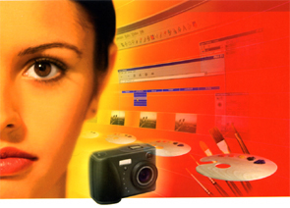
Paint Shop Pro 7 is a wonderful application for creating and editing images, and is great for both novices and experts designers. Jasc® Paint Shop Pro™ 7 contains all the tools you need for creating, editing, and retouching your images.

In this tutorial you will start you WORKSHEET Exercises

Your worksheet will be in the form of a POWER POINT presentation saved to your own folder on the shared students server.

In these exercises you will:

Get to know the toolbar

Rotate images

Change colours

Make borders

Picture Frames

Convert images

Save as various image types

First lets take a look at Paint Shop Pro…A look At The Window

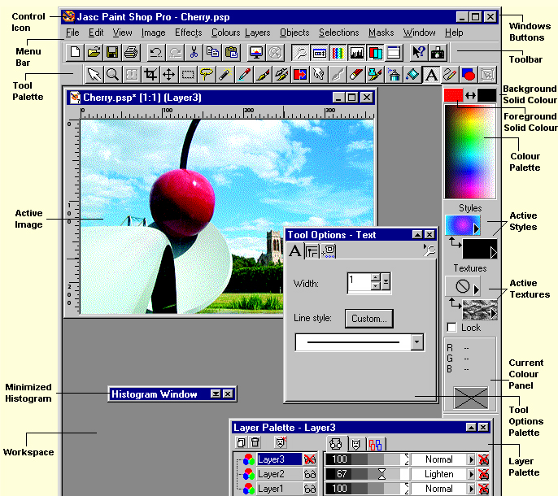
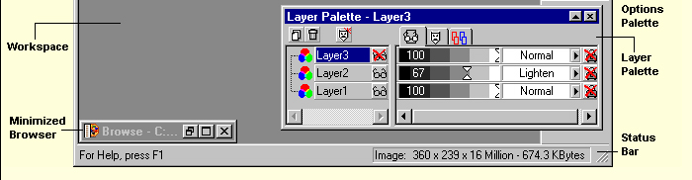

Study the window you will have a test on this in a few minutes

A look at the toolbar

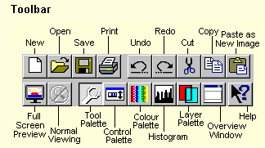

Tools

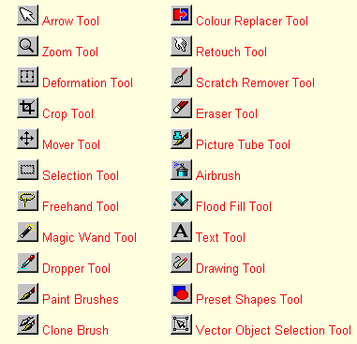

Start The Exercises

- Open your shared folder and create a new folder called "Worksheet Exercises"
- You should store ALL your work here for marking purposes
- Create a new folder called "Paintshop"
- Open Power Point and click on New Click OK
- Create a presentation using your choice of template and colours add the following:
- Your Power Point should contain
  - Your name
  - Title: Class year (01, 02 etc.) Year ?? Your Class (Info Processing, Digital Media etc.)
  - Sub-Title: current year ????
  - Title: My (your name) Worksheet Presentation Folder
  - Make a new slide (2)
  - Slide 2: Title: Task1 Image manipulation

- Save this Power Point presentation to your shared folder (Worksheet Folder) - you should include all working files inside this folder and insert your finished media into your worksheet as instructed.
- In some instances you will be asked to create folders for subjects they should ALL reside inside your folder create a folder now titled "Image Man"

Open Paint Shop Pro

Open the graphic men.jpg

Rotate the image

01 Image Orientation
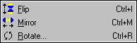

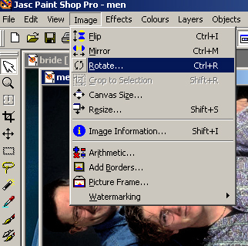

The orientation choices from the Image menu allow you to change the position of a graphic by flipping, mirroring, or rotating.
Each of these commands has a keyboard shortcut that can be used in as an alternative to the menu commands.
The shortcuts are listed beside the menu selection in the graphic above.
The following graphic illustrates, from left to right, an original image, the image flipped, the image mirrored, and the image rotated 90 degrees to the right.

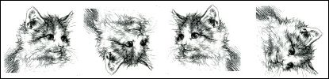

Task 02: Image Orientation
- Open the picture kitten.jpg
- Using the Image Orientation commands – flip the image to be the same as the four kitten samples above so you now have four images.
SAVE
- Save each to your Worksheet Folder - Save in the Image Man Folder
- Open your PowerPoint presentation.
- Select New Slide – Auto Layout 4 Objects. Click OK
- Select each file to fill the four objects and label each object with a separate file name, impagefile01, imageflip02, imageflip03 and imageflip04
- Insert your four new files into the PowerPoint and label each image orientation.
- Save to your Worksheet Folder - Save as My Image Orientation in your Worksheet Folder.

Task 03: Add Borders
- Select one of the four digital images you captured with the Still Digital Camera.
- Add a border. See example above.
- Save as m:\ Add Borders\ Image Man Folder.

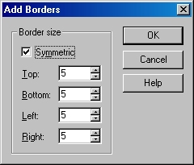
The Add Borders function allows you to add symmetrical or non-symmetrical borders to an image.
The colour of the border added is determined by the currently selected background colour.
The following graphic demonstrates the effect of adding a 5 pixel symmetric border with the background set to black, then a 3 pixel border set to white, then another 5 pixel border.
As you can see, using the borders function can be a quick way to add a frame to a graphic.
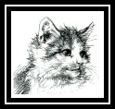

04 Image: Arithmetic
This function combines the pixels of colour between two graphics or changes the pixels of colour in one graphic.
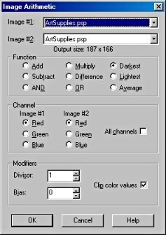
A cool use for this function is to make a colour graphic into a black and white graphic (to use as a mask or template).
The following setting was used to create a black and white graphic out of the colour graphic.




Task 04: Image>Arithmetic
- Select the colour digital image of yourself. (colour_picture.jpg).
- Use the Image Arithmetic Dialog Box to change the colour image to black and white image
- Save as m:\ My Change Colour in your Image Man Folder.

04 Image>Picture Frames
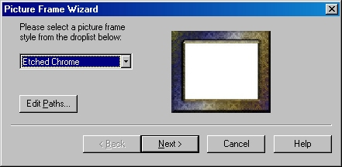

Picture frames were introduced to Paint Shop Pro in Version 6.
This function allows you to add a pre-made frame to any graphic.
There are several frames that install, and there are many additional frames on the CD in the Frames folder.
Frames are very similar to tubes.
Once you have selected the frame you want to use, click on the Next button. Follow the prompts.

Task 05: Image> Picture Frames
- Select one of your digital images.
- Uses the Image Picture Frame Dialog Box add a picture frame to your picture.
- Save to your Worksheet Folder - Save as My Picture Frame\ Image Man Folder.

06 Pencil Sketch: Assessment


There are many tutorials out there that would have you believe creating the pencil sketch effect is difficult but it really can be done just as effectively this way with less hassle.
- Select one of the digital pictures you captured with the Still Digital Camera or from the graphics folder.

- Open up the photo you have selected to turn into a pencil sketch in paint shop.

- Change the colour photo to a black and white photo then:

Select
Colours > Greyscale

- Select
Effects > Artistic Effects > Pencil
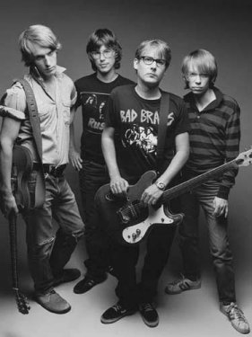

Luminance = 53
blur = 4
intensity = 4
colour = light grey

- Add a Picture Frame to your pencil sketch.
- Save to your Worksheet Folder - Save as mypencilsketch.jpg in your Worksheet folder.

Tips & Tricks

Arrow Tool
When you increase the magnification of an image for detail work, the entire image may no longer fit in the image window. When you want to work on a part of the image that is not in the window, you can move the image with the Arrow tool. Click on the Arrow key and then hold down the left mouse button (the arrow will turn into a hand) and drag your image.

The Crop Tool
The one real use for this tool is that it remembers the last crop setting you used. This can come in quite handy if you need to crop many images to the same size.

To do this

- Make your first crop
- Then, when you want to crop the next image, double click on the Crop tool. This will bring up the Crop Area box
- Click OK,
- You will have a crop area the exact size as your previous crop.

You can move the crop selection by dragging it with the cursor. Double Click on the crop area and you will crop your second image to the exact same size as the first image.

Tutorials

Re-sampling (saving space - file size)

When you want to resize an image but not crop it or add new canvas around it, use the Resize Command. Changing the size of the image is called re-sampling. If you are creating a web page and have an image that is too large to fit, you can resize it. You can also reduce the number of pixels in an image to make it download more quickly.

To open the Resize dialog box, choose Image > Resize or click the optional Resize button on the toolbar.

Select a method for resizing the image. You have three options:

Pixel Size, where you select a new size by choosing a new measurement in pixels,
Percentage of Original, where you select a new size based on a percentage increase or decrease from the original, and
Actual/Print Size, where you select a new size by changing the resolution or the dimensions. Note that the two are linked.

Task 01: Re-sampling
- Select any digital image – the image you select can be a colour or black & white image.
- Using the Re-sampling Commands – increase the Pixel Size by 25% of the original size.
- Save to your Worksheet Folder - Save as Image Man Folder\ Increase Size.
- Click OK
- Select another image.
- Using the Re-sampling Commands – decrease the Pixel Size by 25% of the original size.
- Save to your Worksheet Folder - Save as Image Man Folder\Decrease Size.
- Click OK

